Rladies NYC website: This website can currently be found at <https://www.rladiesnyc.org/>

Our github repo is here: <https://github.com/rladies-nyc>

We will all be sharing the responsibility of Webmaster through 6 month rotations. Ludmila has graciously offered to be our first webmaster until October 2019.

**Steps to updating the website:**

**Step 1:** Get permission to be able to edit the following repos: [source](https://github.com/rladies-nyc/source) and [rladies-nyc.github.io](https://github.com/rladies-nyc/rladies-nyc.github.io)

**Step 2:** Clone both repositories and make sure you use the original source project files to make the updates.

**Step 3:** Add a new post by:

* going to the **source** repo (which updates the the rladies-nyc.github.io, as that contains the Cname, .nojekyll file)
* creating a new markdown file (.md, not .Rmd) and save to source/content/post (the best way to do this is to just open a new text file and save it with the extension .md)
* Name the file with the date (in YYYY-MM-DD format and leading zeros if needed) and info, eg 2019-05-09-book-club-how-not-to-be-wrong
* Enter the post information (the easiest thing to do is copy an earlier event and edit it as needed), eg

---

title: Book Club Meeting

author: Ludmila Janda

date: '2019-05-09'

slug: book-club-how-not-to-be-wrong

categories:

- bookclub

- event

tags:

- bookclub

- event

---

Join us to discuss **How Not To Be Wrong** by Jordan Ellenberg

Date: Saturday, May 25th, 2019

Time: 2:00pm

Host: Rizzoli Bookstore, 1133 Broadway (between 25th & 26th)

**Step 4:** Once you have updated the source directories then you need to build the website and push the updated repo back to github. You can navigate to the “build” tab (near “environment”) and hit “build website”

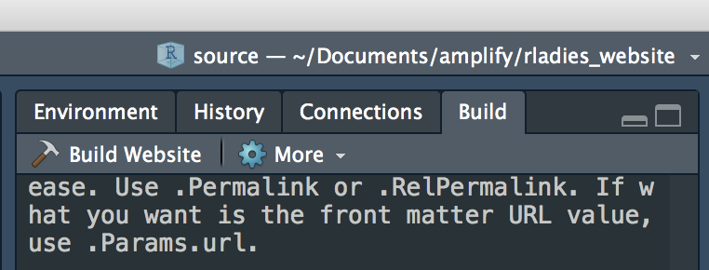

**Step 5:** Then you need to add, commit, and push BOTH the “source” and “rladies-nyc.github.io” repos

* You can “add .” and use the same commit message for both repos
* make sure there is no .Rroj file getting pushed with the “rladies-nyc.github.io” repo - you can always put it in your .gitignore file, but there is never a need to make an R project for the “rladies-nyc.github.io” repo, so best to just avoid doing that

Note: MAKE SURE TO GIT PULL BEFORE MAKING ANY UPDATES!

To do:

Transfer of ownership of the rladiesnyc.org domain from Emily Zabor to the [nyc@rladies.org](mailto:nyc@rladies.org). (Completed)